**Year 12 Essentials 2021**

**Test 2**

# Data Collection and Graphs

**Name:** _________________________________

Time for the task: 50 minutes

Resources allowed – Calculator, 1 A4 (one side) hand-written page of notes **Total Marks:** / 43

**Task weighting:** 8%

***Full working out must be shown to get full marks.***

***Attempt all questions in the space provided.***

|  |
| --- |
| **Question 1 [4 marks; 1 each]** |

Classify each of the following data collections according to whether they are a sample or census.

1. Favourite film of secondary school students by surveying students in Year 12.
2. Number of hours spent completing maths homework each week by your class by surveying each student in your class.
3. Survey every 10th person in town to find out the towns average income.
4. Asking everybody in the family what their favourite dessert is to decide what to cook for dinner.

|  |
| --- |
| **Question 2 [6 marks; 3 each]** |

For each of the following investigations;

* State the population to be surveyed,
* Decide if a census or a sample should be used in collecting data.
* Give a reason for your answer.

1. Student opinions of the length of lunch break at Baldivis Secondary College
2. Find the average number of people in an Australian family.

|  |
| --- |
| **Question 3 [2 marks; 1 each]** |

Give an example of how each of these sampling methods can be conducted.

1. Random sampling:
2. Systematic sampling:

|  |
| --- |
| **Question 4 [4 marks]** |

Belinda jumps out of planes for fun. This can be represented by the linear function *h* = 1200 – 10*t*, where *h* is her height above ground at *t* seconds after she has opened her parachute.

Complete the table of vales for this function.

|  |  |  |  |  |
| --- | --- | --- | --- | --- |
| Time, *t* seconds | 0 | 30 | 60 | 90 |
| Height, *h* metres |  |  |  |  |

|  |
| --- |
| **Question 5 [4 marks; 2 each]** |

Why are the following survey questions biased?

Rewrite the question so that it is unbiased.

1. Are there enough events for young people in boring Baldivis?
2. Rate how happy you are with the phone service in Baldivis:

□ Good □ Very Good □ Excellent

|  |
| --- |
| **Question 6 [4 marks; 2 each]** |

In what way are the following samples biased? How could you get an unbiased sample?

1. Surveying the maths teachers on what is the best subject at school?
2. Asking teachers what music should be played at the Year 12 ball?

|  |
| --- |
| **Question 7 [13 marks]** |

The table shows the linear relationship between the length of an international mobile phone call and the cost of the call.

**BEBO INTERNATIONAL MOBILE PHONE PLAN**

|  |  |  |  |
| --- | --- | --- | --- |
| **Length of call (minutes)** | **1** | **2** | **3** |
| **Cost (dollars)** | **7.7** | **14.5** | **21.3** |

1. Draw the graph of the mobile phone plan on the axis below. **[2 marks]**

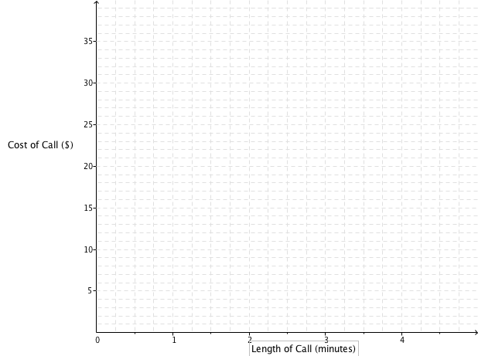

1. What is the cost of a 4-minute phone call on this BEBO phone plan? **[1 mark]**
2. What is the cost per minute for the BEBO phone calls? **[2 marks]**
3. What is the rule to calculate the cost (c) of a phone call of (m) minutes on the BEBO phone plan?

**[3 marks]**

1. GINTS international phone plan uses the formula c = 3.2m + 10. Draw this on the axis above.

**[3 marks]**

1. Which mobile plan is better if I plan to make a phone call of 1.5 minutes? How much better would it be? **[2 marks]**

|  |
| --- |
| **Question 8 [6 marks; 3 each]** |

Amy owns a bakery that makes cupcakes. It costs $2500 per month to cover rent, electricity and wages in the cafe. Each cupcake costs $1.10 to make and sells for $2.50.

1. How many cupcake does Amy need to make and sell per month to break even?



1. What profit or loss will she make in a month if she makes and sells 2500 cupcakes?

**End of Test**